Water Ordering 101:

KRD receives our water allotment from the US Bureau of Reclamation. The water itself is diverted from Lake Easton. Once water is started down the the 300+ miles of canal system, KRD will fill the Main, North and South Branch canals. When the larger canals are filled, the sub-laterals will then be filled as needed. Any leaks or problems will be repaired as the water comes down the system. When complete, KRD is ready to start delivering water to landowners. This date is roughly mid-April. It can take up to a week or more to get the canal system ready.
How much water do I get and when is water season?
Based on a 100% supply, your water allotment is 2.5 cfs (5.0-acre feet) per assessed acre for the season. The water turn-on date will be announced by the KRD Board as early in April as possible. Weather and maintenance will determine the exact turn-on date. The Board will announce the turnoff date no later than October 6.
What is a water order?
The water that you see in the canal today likely belongs to a landowner that requested water several days ago. If KRD tried to deliver water to every landowner at the same time the canal system would be overwhelmed and likely damaged. In order to manage the delivery of water and make sure the system can handle the requests, KRD employs Ditch Riders. These workers go out into the field and turn on/off water for landowners who have ordered water. When ready to irrigate, landowners are to call their Ditch Rider to “place an order” letting us know that your system is ready. When you’ve placed a water order, it can take anywhere from 12-48 hours to bring the water down to your land.
How can I place an order?
Kittitas Reclamation District (KRD) takes water orders Monday through Friday from 7am to 7:45am. Please call 509-925-6158 during that time to speak to your Ditch Rider. Orders may also be placed with office staff from 7:45 A.M. to 5 P.M. Monday – Friday, HOWEVER, those orders will not be given to the ditch rider until the next morning. The answering service will not take water orders. The afterhours answering service is for emergencies only.
There are no water orders or changes to deliveries on Saturday or Sunday. It is best to give your ditch rider forty-eight (48) hour notice to ensure timely delivery. The District also has a forty-eight (48) hour notice with the Bureau of Reclamation to change its diversion at Easton. Mondays and Fridays are the most difficult days to receive "same day" deliveries. We should have your order in by Thursday 07:45 to deliver your water on Monday. The Ditch Riders will attempt to service their rides following the same route daily so you will be able to anticipate when your water will be adjusted.
Who is my Ditch Rider?
If you do not know who your Ditch Rider is, please take a look at the Maps section of the KRD website. The first map on the page shows the different “Rides” for each Ditch Rider. They are approximately as follows:
Ride 1 – Ditch Rider: Nick Newton, Location: West of Ellensburg, in the Manastash Rd, Weaver Rd, Robinson Canyon Rd areas.
Ride 2 – Ditch Rider: Justin Nunley, Location: Hayward Hill (Yakima Pressure Tunnel Outlet to Naneum Rd area.
Ride 4 – Ditch Rider: Doug Webster, Location: Naneum Rd and east to KRD boundary, South to Sorenson Rd, Hamilton Rd area.
Ride 5 – Ditch Rider: Marty Haberman, Location: Badger Pocket area
Ride 6 – Ditch Rider: Chris Sandvig, Location: Upper Kittitas County
Ride 7 – Ditch Rider: David Mayer, Location: East of Ellensburg, Pumping Plant Rd area.

General Water Measurement Information:
1 cubic foot per second (cfs) = 2 acre feet in 24 hours.
1 cubic foot per second (cfs) = 1 acre inch per hour.
1 cubic foot per second (cfs) = 450 gallons per minute.
1 cubic foot per second (cfs) = 7.5 gallons per second.
1 cubic foot per second (cfs) = 50 California miner inches.
1 California miner inch = 9 gallons per minute.
1 acre foot = the amount of water required to cover one acre, one foot deep.
1 acre foot = 325,850 gallons.
How do you calculate water for your order?
To figure inches of water applied during an irrigation: Multiply cfs at your farm turnout by time in hours and divide by acres being irrigated.
Example: 2 cfs applied to 6 acres in 12 hours.
2 cfs x 12 hours = 4 inches applied
6 acres
KRD's annual allotment in a 100% water year is 2.5 cfs per acre of assessed land owned.
If you own 20 acres your allotment will be 50 cfs for the irrigation season (2.5x20).

Gauge Height Readings
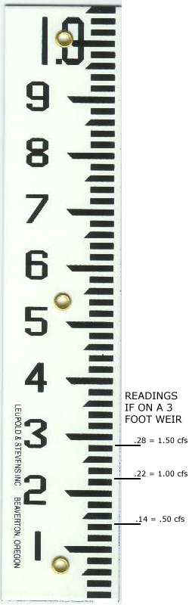
(Cubic Foot per Second given to closest tenth)

New Landowners Tip! Call your Ditch Rider at the beginning of the season (early April). Most of the Ditch Riders will be familiar with your parcel and able to tell you how much water was typically ordered by previous landowner.

Miner’s  Inches | Cubic Feet per  Second | Acre Feet  in 24 Hours | Gage Height (ft.)
 |  |  | 2 Foot Weir | 3 Foot Weir | 4 Foot Weir
25 | 0.5 | 1 | 0.18 | 0.14 | 0.11
50 | 1.0 | 2 | 0.28 | 0.22 | 0.18
75 | 1.5 | 3 | 0.37 | 0.28 | 0.23
100 | 2.0 | 4 | 0.45 | 0.34 | 0.28
125 | 2.5 | 5 | 0.52 | 0.40 | 0.33
150 | 3.0 | 6 | 0.59 | 0.45 | 0.37
175 | 3.5 | 7 | 0.65 | 0.49 | 0.41
200 | 4.0 | 8 | 0.71 | 0.54 | 0.45

